Emergent Bilinguals Support Guidelines

Emergent Bilinguals support is focused on an asset-based approach to learning. We want to highlight what the students can do to show their understanding of learned content. We are looking to amplify the mathematical content for students, not simplify it. Language supports need to be scaffolded based on language proficiency to provide appropriate assistance to learners while maintaining the rigor of the task. It is important to note that mathematically challenging components should not be reduced while providing language supports for Emergent Bilinguals. Language supports include productive high-level activities beyond vocabulary learning. All supports need to be designed to help learners make meaning of the content through collaborating, interpreting, as well as producing and extending their mathematical understanding and language.

There will be Emergent Bilinguals support at point of use throughout each lesson. All the support being authored needs to directly support the mathematical concept being taught in the task that the support is located in. The locations of these supports are as follows:

Language Objective
Learning Goal
Spark Your Learning
Spark Your Learning Turn and Talk
Task Turn and Talk
Review Spark Your Learning
Quick Check

Before you Teach - Language Objective:
The Language Skill/Domain used in the Learning Objective will be used to drive the provided EB support within the lesson. Whichever domain(s) is used in the learning objective will determine which type of EB support is chosen throughout the lesson.

To write the Language Objective, consider the following pieces:
- Learning Objective of the lesson
- Process Standard in the lesson
- Language Skills/Domains for the lesson

Begin writing the Language Objective by reviewing the Learning Objective to identify the lesson content that the students will be using the Language Objective to show an understanding of.

Then, use the Process Standard(s) addressed in the lesson to determine what students are using the domain to do.

Finally, select an appropriate Language Domain (reading, writing, listening, speaking, viewing, or representing.) If the lesson has more than one domain, focus on the output domain (speaking, writing, or representing). The language objective should use a verb that explicitly tells what domain was selected, such as:
- Orally…
- Write…
- Represent…
Example 1:

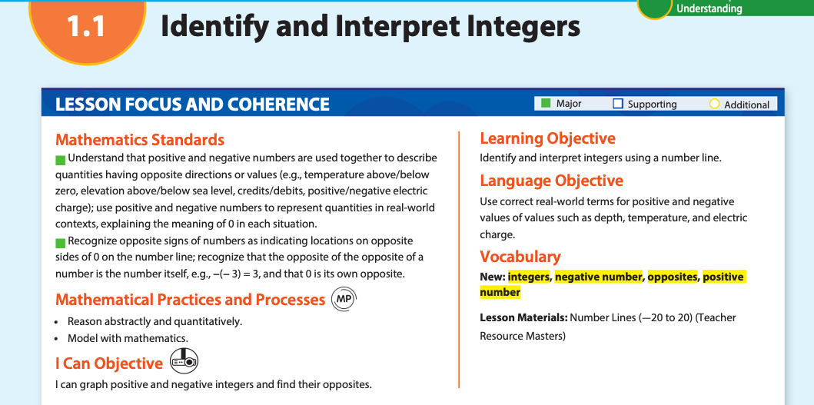
Learning Objective: Identify and interpret integers using a number line.

Process Standard(s): Reason abstractly and quantitatively; Model with mathematics

Language Domain: Writing

New Language Objective: Write to explain how to identify and interpret integers in a number line using varied and precise vocabulary.

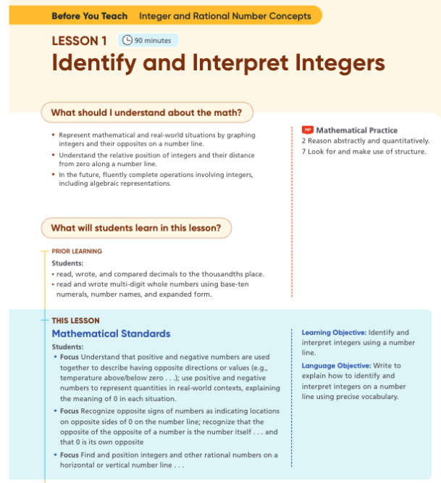
Example 2:

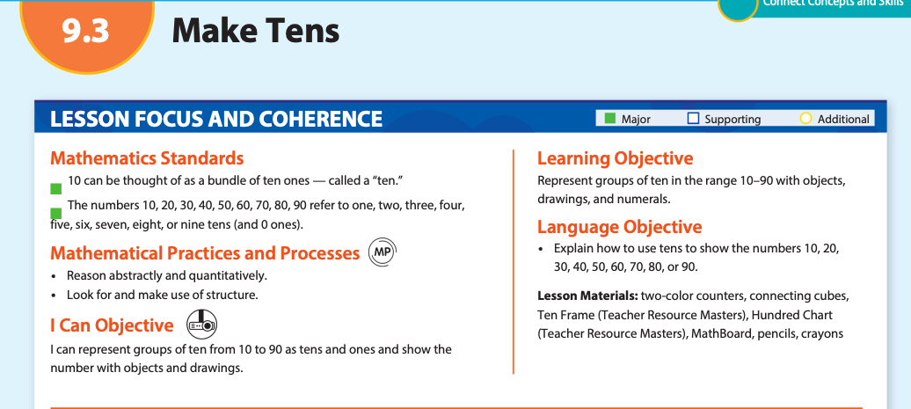
Learning Objective: Represent groups of tens in the range 10-90 with objects, drawings, and numerals.

Process Standard(s): Reason abstractly and quantitatively; Look for and make use of structure

Language Domain: Representing

New Language Objective: Show how to use objects, drawings, and numerals to represent groups of tens from 10-90 connecting the relationship between the representations.

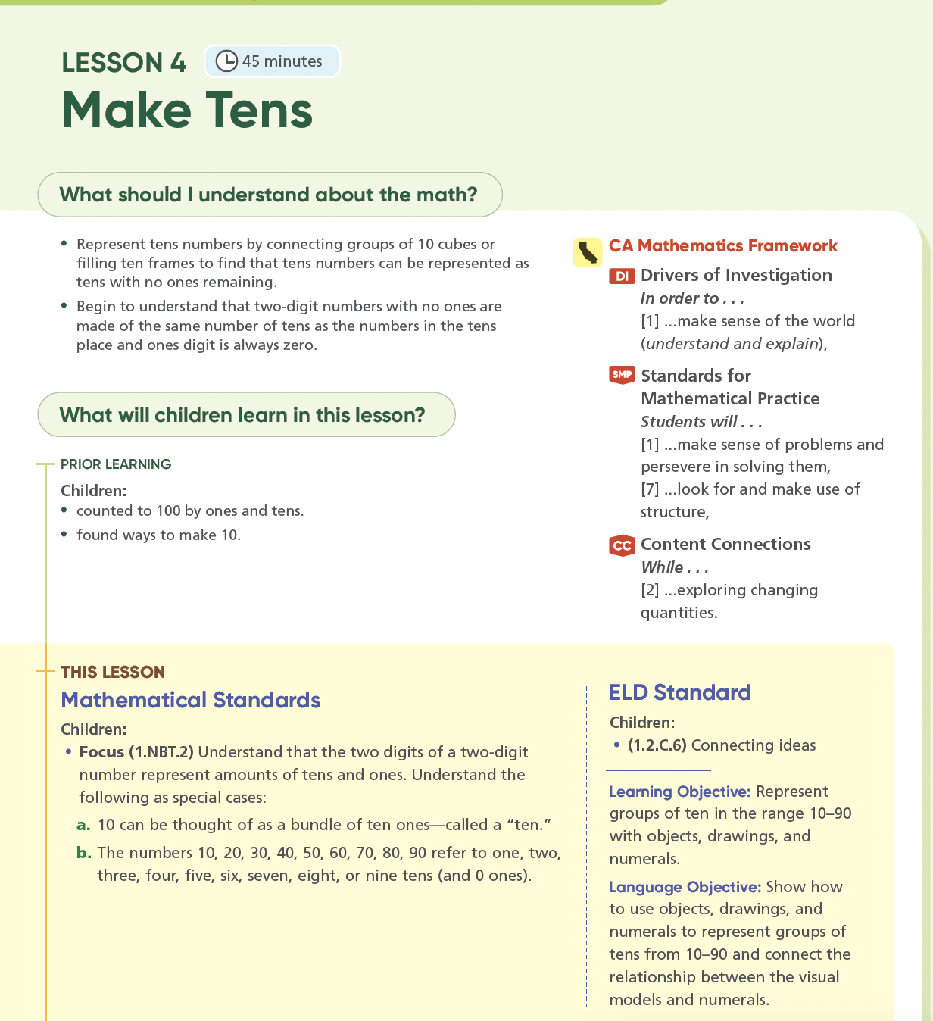

Learning Goal:

The teacher notes of the learning goal will have teacher-specific support for clarifying vocabulary in the I Can Objective. Select one or two terms for clarification and instruct the teacher on how to clarify the meaning. Not all words chosen need to be math academic vocabulary. For any math specific terms, please refer to the definition found in the Vocabulary Tracker.

- Example 1:

Possible EB Support: Clarify the meaning of compose to help with student understanding. Draw a shape and explain to students that in this lesson compose means to make or create a shape by combining multiple shapes

- Example 2:
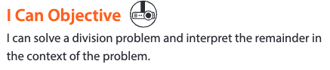
Possible EB Support: Clarify the meaning of interpret by explaining it means to understand and the meaning of context by explaining it means situation.

- Example 3:
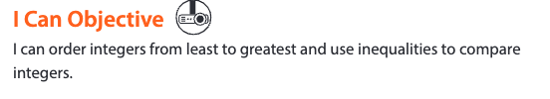
Possible EB Support: Clarify the meaning of integers and inequalities by reminding the students that integers include zero (0), positive, and negative numbers and informing them that inequalities are mathematical sentences that show the relationship between quantities with showing the inequality symbols.

Spark Your Learning:

Use the EB Resources document as a toolbox to select a support strategy based on the language domain selected for the Language Objective. Use the examples in the toolbox as a guide in authoring new support specific to the content of the task. Do not copy and paste the examples as is. Be sure to vary the strategies used from lesson to lesson.

- Turn and Talk Emergent Bilinguals Teaching Strategy:
  - Select a Strategy from the EB Resources document from the Language Domain selected for the Language Objective. The domain informs how the students interact with the content. For example, if the domain is only speaking, then you need to use the strategies for supporting students speaking. In some lessons, the domains may be representing/speaking. For those lessons, you can use the strategies in both the speaking and the representing categories.
  - Provide teachers with support in understanding the goal of the strategy, example scripting and resources can be found in the EB Resource spreadsheet.
  - After the teaching strategy, include the boilerplate: Use the Supporting All Language Learners chart to let students choose the language scaffolding that they need.

Example:
Use the sentence frames and sentence starters to support students’ discussions and written explanations. Encourage Emergent Bilinguals students to speak in their home language and use their models to support their explanation. Ask students to write their responses to describe how to interpret the remainder.

Use the Supporting All Language Learners chart to provide language scaffolding for all proficiency levels.

*Avoid telling the students what order they should complete the speaking, writing, and/or representing. Students may have a preference in which order they complete the tasks, and we should allow them to decide if appropriate.

- Turn and Talk Tool Table:
  - Use the strategy selected in the Turn and Talk Emergent Bilinguals Teaching Strategy box.
  - Use the EB Resource document to find examples and resources for authoring the differentiated support based on the Language Domain.
  - The strategy must be differentiated to represent support for the following Language Proficiency Levels:
    - Pre-Production/Beginning
    - Intermediate
    - High Intermediate/Advanced

Example with CA Proficiency Levels:

Supporting All Language Learners
Language Proficiency Level |  |  | Scaffolding Examples
Pre-Production/Beginning | Use sentence frames with or without a word bank to support students in their written explanation of interpreting remainders. | The remainder is ____.  The car needs ____ wheels.  Aiden ____ make a car with the remainder.  Bank:  4 2 can cannot
Intermediate | Use sentence frames to support students in their written explanation of interpreting remainders. | The whole number quotient is ____, and the  remainder is ____.  Aiden can make ____ cars because ____.
High Intermediate/Advanced | Use sentence starters to support students in their written explanation of interpreting remainders. | I think the remainder means ____.

- Review Spark Your Learning
  - Select a Strategy from the EB Resources spreadsheet.
  - Use the EB Resource document to find examples and resources for authoring the differentiated support.
  - This support will always be focused on student discussion and communicating learning growth.
  - The example below is not boilerplate. Please use a variety of approaches to support discussion.

Example:
Use sentence starters to support students' discussion.
Before I solved the problem by______.
Now I would solve the problem by______.

Task or Task Turn and Talk:
- Select a strategy from the EB Resources document.
- The support found in the Tasks can call back to and be linked to the previously used strategy in the SYL table if appropriate, but it needs to include an example of how to apply the strategy to the content of the task.
- This support will not include a table with proficiency-based support, so be sure to provide the teacher with a clear understanding of how to support their students. See Example Teaching Support in the EB Resources tracker for scripting examples and resources.
- Be sure the support correlates directly with the content of the Task or Turn and Talk.

Example for this Turn and Talk:

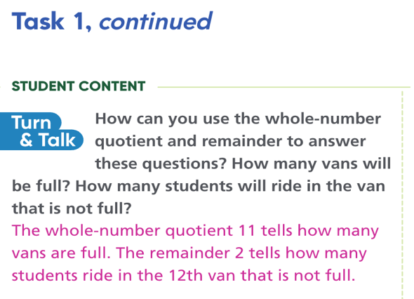

Use sentence frames, sentence starters, and/or banks similar to the con those from the Emergent Bilinguals Teaching Strategy earlier in the lesson as tools to support their writing to explain how they interpret the remainder.

The whole number quotient tells ____.
The remainder tells ____.

Quick Check:
- In the teacher notes include the following boilerplate followed by lesson specific information:
“To measure students’ mastery of the language objective, ask them to...”
Complete the sentence so that it reflects what teachers will be measuring based on the domain in the Language Objective. For example,
  - For the writing domain: “...write and explanation of [rephrase Language Objective].
  - For the speaking domain: “...orally explain [rephrase Language Objective].
  - For the representing domain: “...use [manipulatives, visual models, equations, etc.] to show [rephrase Language Objective].
Example in Teacher Notes: To measure students’ mastery of the language objective, ask them to write an explanation of what the remainder of this problem means and describe how to use it to solve the problem.
- When writing or speaking is the output Language Skill/Domain use the boilerplate: “Use similar scaffolds to those provided in the Emergent Bilinguals Teaching Strategy for Spark Your Learning to ensure the students have appropriate [writing/speaking] supports.”
- When representing is the Language Skill/Domain for the lesson, use this boilerplate: “Use similar scaffolds to those provided in the Emergent Bilinguals Teaching Strategy for Spark Your Learning to ensure the students have appropriate supports to represent their work.”

After Quick Check:
Use the boilerplate with the appropriate domain: Use similar scaffolds to those provided in the Emergent Bilinguals Teaching Strategy for Spark Your Learning to ensure the students have appropriate [speaking, writing] supports.

Use similar scaffolds to those provided in the Emergent Bilinguals Teaching Strategy for Spark Your Learning to ensure the students have appropriate supports to represent their work.

Followed by task specific support using a strategy previously used in the lesson.
Example: The remainder in this problem are the ____. I need to ____ so there are enough batteries.

